Федеральное агентство связи

Федеральное государственное бюджетное образовательное учреждение высшего образования

«Сибирский государственный университет телекоммуникаций и информатики»

Кафедра прикладной математики и кибернетики

Отчет по лабораторной работе

по дисциплине «Визуальное программирование»

Лабораторная работа № 3

«Графические редактор»

Выполнил: студент 2 курса группы ИП-811 Мироненко К. А

Проверил: доцент кафедры ПМиК Ситняковская Е. И.

**Оглавление**

1. Постановка задачи 3

2. Описание работы 4

3. Примеры работы программы 5

*Приложение* Листинг 9

# Постановка задачи

Создание графического редактора, позволяющего:

1. Создавать, редактировать, загружать, сохранять изображения;
2. Рисовать с помощью мыши (при нажатии левой кнопки мыши и её перемещении отображается кривая движения указателя мыши. При нажатии правой кнопки мыши появляется стирательная резинка);
3. Задавать цвет, толщину и стиль линии;
4. Пользоваться историей изменений в обе стороны – undo и redo.
5. Отдельная форма для выбора цвета пера

# Описание работы

Работа приложения соответствует описанию в методичке, за исключением именования и свойств некоторых элементов.

# Примеры работы программы

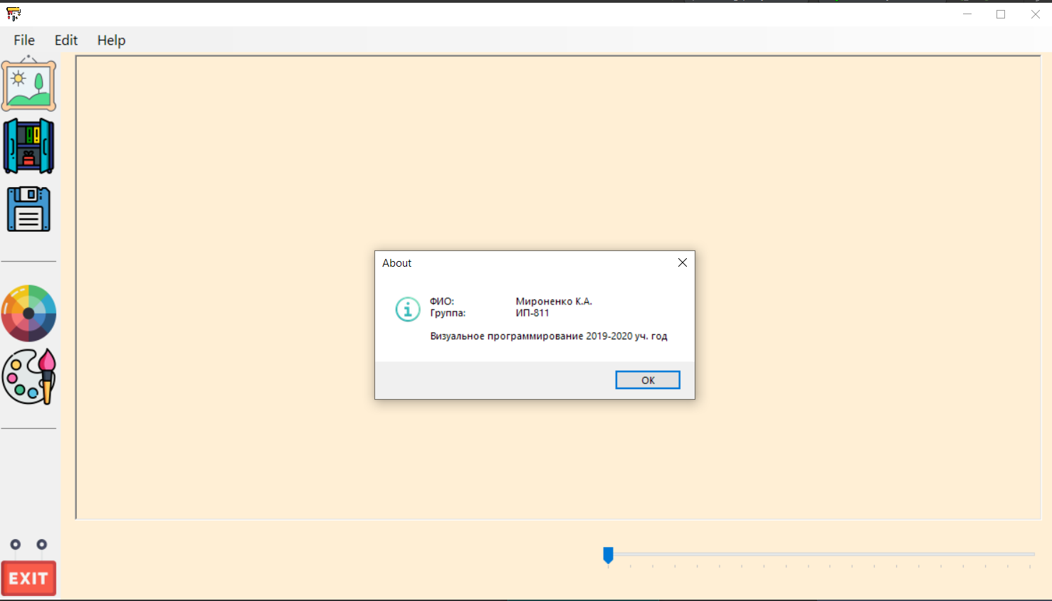

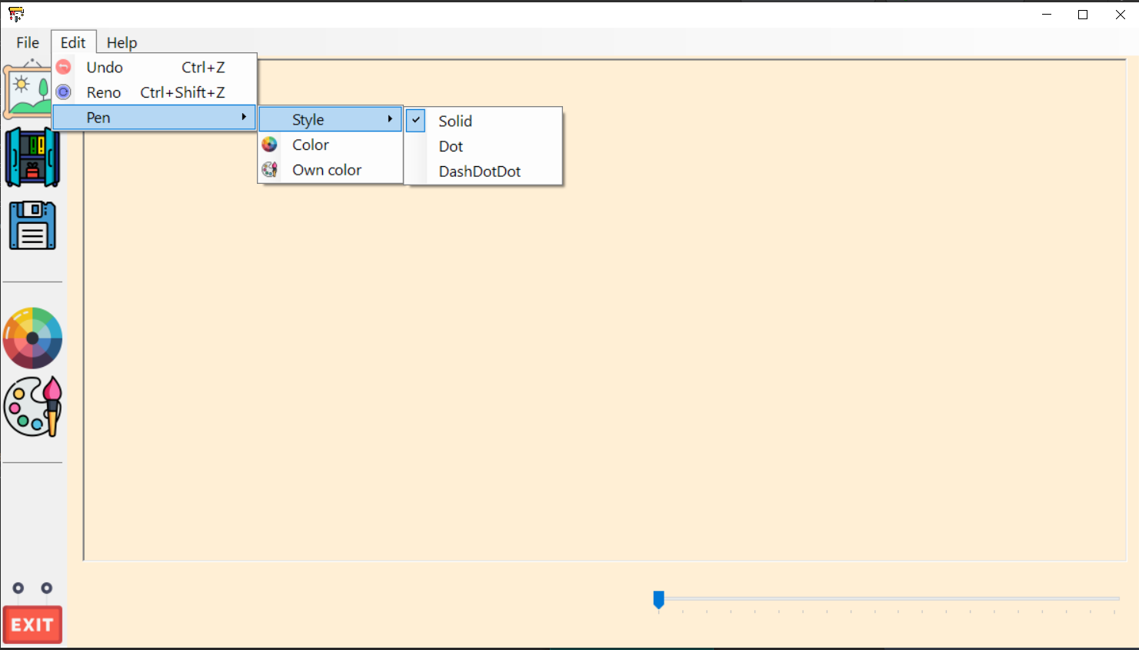

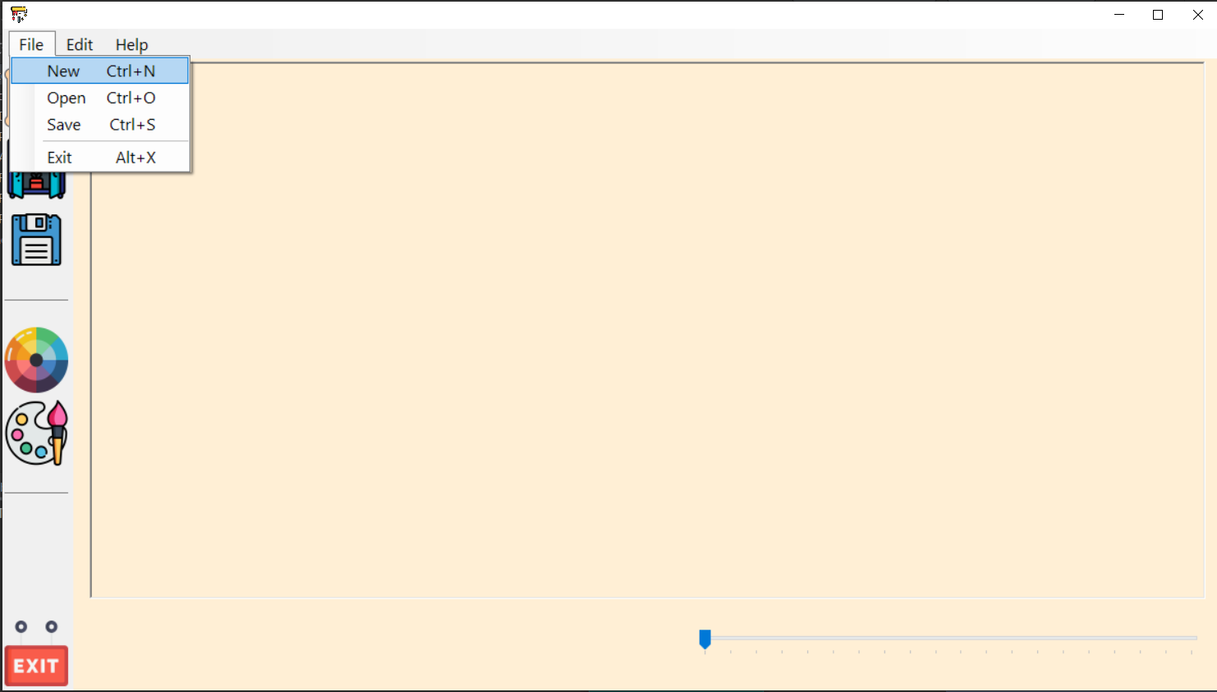

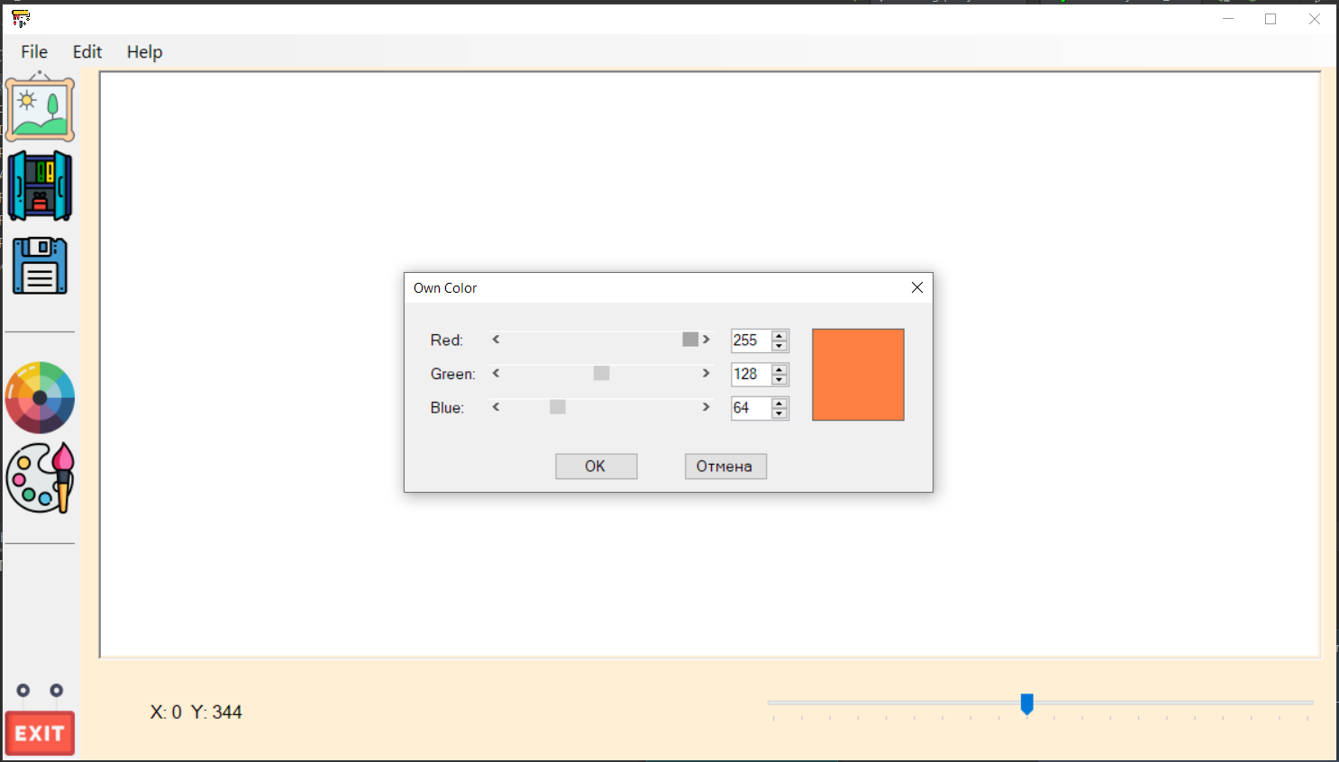

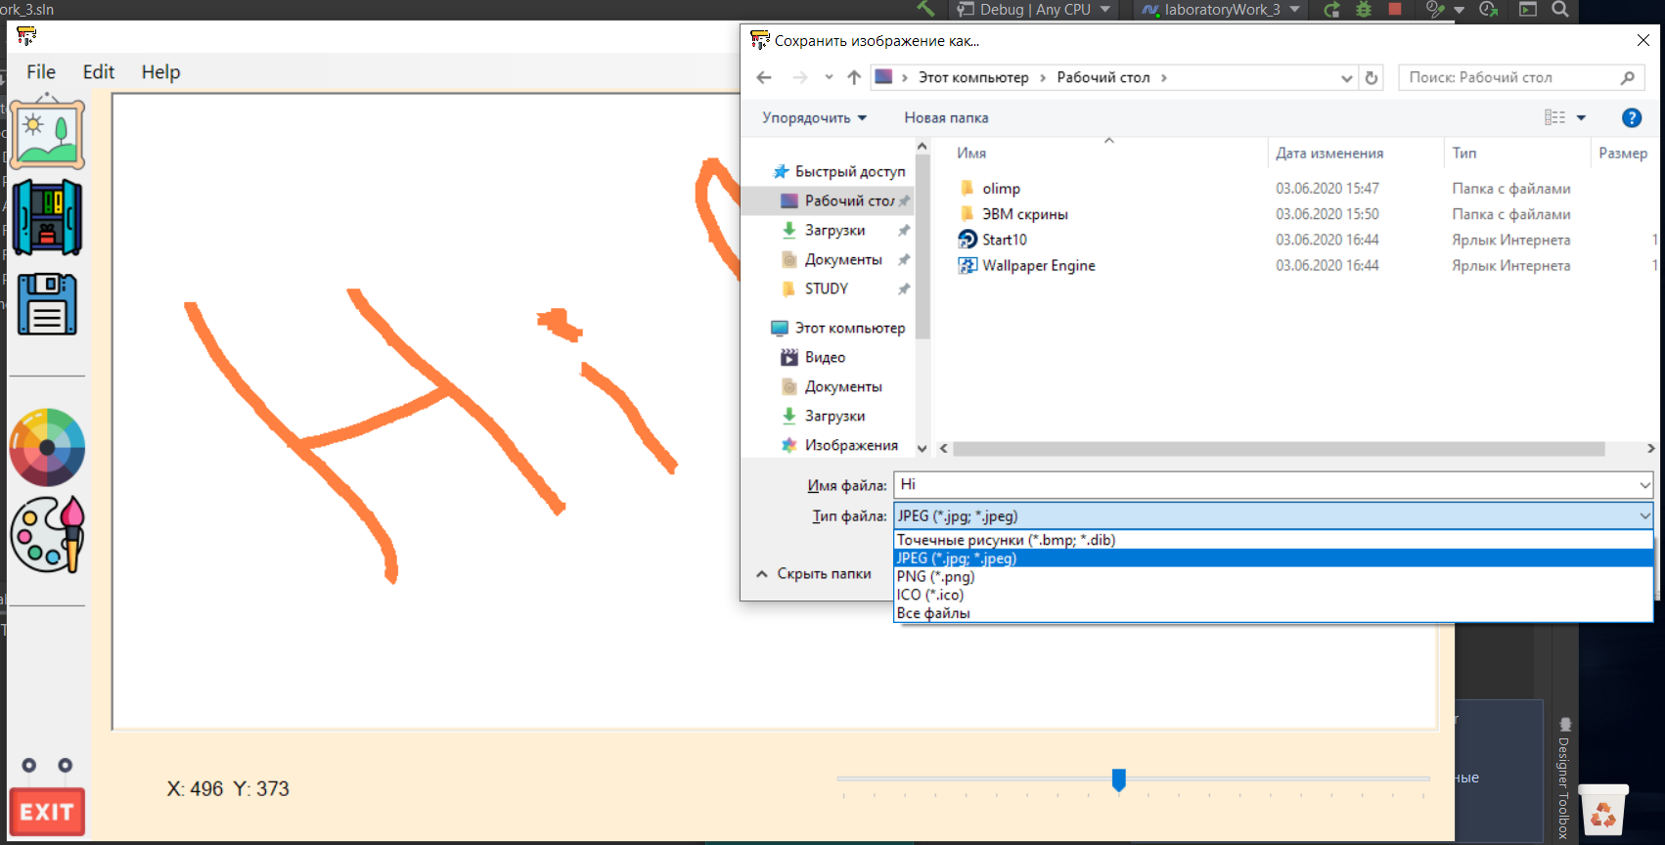

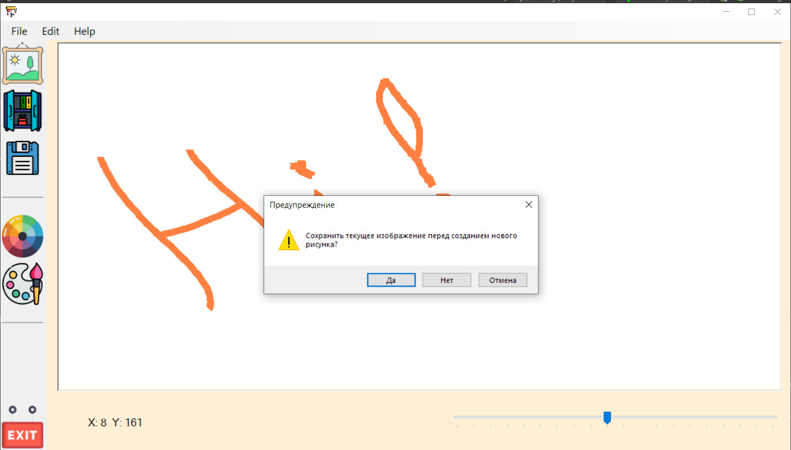

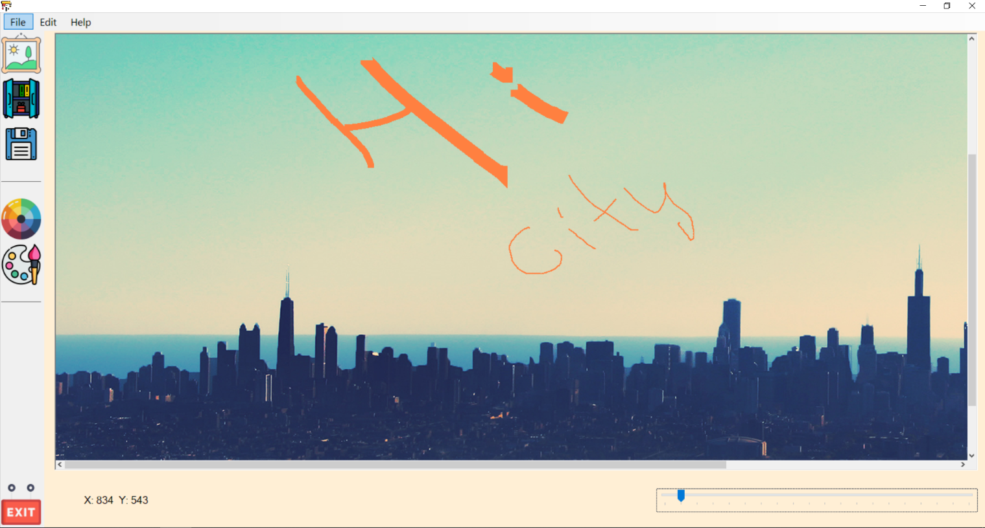

# *Приложение* Листинг

**Program.cs**

using System;

using System.Collections.Generic;

using System.Linq;

using System.Threading.Tasks;

using System.Windows.Forms;

namespace laboratoryWork_3

{

static class Program

{

/// <summary>

/// The main entry point for the application.

/// </summary>

[STAThread]

static void Main()

{

Application.EnableVisualStyles();

Application.SetCompatibleTextRenderingDefault(false);

Application.Run(new FormMain());

}

}

}

**FormMain.cs**

using System;

using System.Collections.Generic;

using System.ComponentModel;

using System.Data;

using System.Drawing;

using System.Drawing.Drawing2D;

using System.Linq;

using System.Text;

using System.Threading.Tasks;

using System.Windows.Forms;

namespace laboratoryWork_3

{

public partial class FormMain : Form

{

private bool drawing;

private GraphicsPath currentPath;

private Point oldLocation;

private Color currentColor;

private Pen currentPen;

private int historyCounter;

private int currentRecordHistory;

private List<Bitmap> history;

public FormMain()

{

InitializeComponent();

drawing = false;

currentColor = Color.Black;

currentPen = new Pen(currentColor, PenWigth_trackBar.Value);

historyCounter = 10;

history = new List<Bitmap>();

currentRecordHistory = -1;

}

private void aboutToolStripMenuItem_Click(object sender, EventArgs e)

{

MessageBox.Show(

"ФИО:\t\tМироненко К.А.\nГруппа:\t\tИП-811\n\nВизуальное программирование 2019-2020 уч. год",

"About",

MessageBoxButtons.OK,

MessageBoxIcon.Information);

}

private void exitToolStripMenuItem_Click(object sender, EventArgs e)

{

Application.Exit();

}

private void saveToolStripMenuItem_Click(object sender, EventArgs e)

{

SaveFileDialog dlg = new SaveFileDialog();

dlg.Filter = "Точечные рисунки (*.bmp; *.dib)|*.bmp; *.dib|JPEG (*.jpg; *.jpeg)|*.jpg; *.jpeg|PNG (*.png)|*.png|ICO (*.ico)|*.ico|Все файлы|*.*";

dlg.FilterIndex = 2;

dlg.RestoreDirectory = true;

dlg.Title = "Сохранить изображение как...";

if (dlg.ShowDialog() == DialogResult.OK)

{

try

{

paintBox.Image.Save(dlg.FileName);

}

catch

{

MessageBox.Show(

"Ошибка! \n Не удалось сохранить файл! \n Проверьте права на запись в дирректории для сохранения",

"Упс! Что-то пошло не так...",

MessageBoxButtons.OK,

MessageBoxIcon.Error);

}

}

dlg.Dispose();

}

private void openToolStripMenuItem_Click(object sender, EventArgs e)

{

if (paintBox.Image != null)

{

var result = MessageBox.Show(

"Сохранить текущее изображение перед открытием нового изображения?",

"Предупреждение",

MessageBoxButtons.YesNoCancel,

MessageBoxIcon.Warning);

switch (result)

{

case DialogResult.No: break;

case DialogResult.Yes:

saveToolStripMenuItem_Click(sender, e);

history.Clear();

currentRecordHistory = -1;

break;

case DialogResult.Cancel: return;

}

}

OpenFileDialog dlg = new OpenFileDialog();

dlg.Filter = "Точечные рисунки (*.bmp; *.dib)|*.bmp; *.dib|JPEG (*.jpg; *.jpeg)|*.jpg; *.jpeg|PNG (*.png)|*.png|ICO (*.ico)|*.ico|Все файлы|*.*";

dlg.FilterIndex = 2;

dlg.RestoreDirectory = true;

dlg.Title = "Открыть изображение...";

if (dlg.ShowDialog() == DialogResult.OK)

{

try

{

paintBox.Image = new Bitmap(dlg.FileName);

}

catch

{

MessageBox.Show(

"Ошибка! \n Не удалось открыть файл! \n Возможно файл не является изображением!",

"Упс! Что-то пошло не так...",

MessageBoxButtons.OK,

MessageBoxIcon.Error);

}

}

dlg.Dispose();

addRecordHistory();

}

private void newToolStripMenuItem_Click(object sender, EventArgs e)

{

if (paintBox.Image != null)

{

var result = MessageBox.Show(

"Сохранить текущее изображение перед созданием нового рисунка?",

"Предупреждение",

MessageBoxButtons.YesNoCancel,

MessageBoxIcon.Warning);

switch (result)

{

case DialogResult.No: break;

case DialogResult.Yes:

saveToolStripMenuItem_Click(sender, e);

history.Clear();

currentRecordHistory = -1;

break;

case DialogResult.Cancel: return;

}

}

paintBox.Size= new Size(flowLayoutPanel.Size.Width-6,flowLayoutPanel.Size.Height-6);

var image = new Bitmap(flowLayoutPanel.Size.Width-6,flowLayoutPanel.Size.Height-6);

paintBox.Image = image;

var g = Graphics.FromImage(paintBox.Image);

g.Clear(Color.White);

g.Dispose();

paintBox.Invalidate();

addRecordHistory();

}

private void colorToolStripMenuItem_Click(object sender, EventArgs e)

{

ColorDialog dlg = new ColorDialog();

if (dlg.ShowDialog() == DialogResult.OK)

{

currentColor = dlg.Color;

currentPen.Color = currentColor;

}

dlg.Dispose();

}

private void ownColorToolStripMenuItem_Click(object sender, EventArgs e)

{

FormColorSelection dlg = new FormColorSelection();

dlg.Owner = this;

if (dlg.ShowDialog() == DialogResult.OK)

{

currentColor = dlg.Color;

currentPen.Color = currentColor;

}

}

private void paintBox_MouseDown(object sender, MouseEventArgs e)

{

if (e.Button == MouseButtons.Left)

{

drawing = true;

oldLocation = e.Location;

currentPath = new GraphicsPath();

}

if (e.Button == MouseButtons.Right)

{

drawing = true;

currentPen.Color = Color.White;

oldLocation = e.Location;

currentPath = new GraphicsPath();

}

}

private void paintBox_MouseUp(object sender, MouseEventArgs e)

{

addRecordHistory();

drawing = false;

try

{

currentPath.Dispose();

}

catch { };

currentPen.Color = currentColor;

}

private void paintBox_MouseMove(object sender, MouseEventArgs e)

{

if (drawing)

{

Graphics g = Graphics.FromImage(paintBox.Image);

currentPath.AddLine(oldLocation, e.Location);

g.DrawPath(currentPen, currentPath);

oldLocation = e.Location;

g.Dispose();

paintBox.Invalidate();

}

MousePosition_textBox.Text = "X: " + e.X.ToString() + " Y: " + e.Y.ToString();

}

private void PenWigth_trackBar_Scroll(object sender, EventArgs e)

{

currentPen.Width = PenWigth_trackBar.Value;

}

private void addRecordHistory()

{

try

{

history.RemoveRange(currentRecordHistory + 1, history.Count - currentRecordHistory - 1);

}

catch{ }

history.Add(new Bitmap(paintBox.Image));

if (currentRecordHistory + 1 < historyCounter)

currentRecordHistory += 1;

if (history.Count() > historyCounter + 1)

{

history.RemoveAt(0);

}

}

private void undoToolStripMenuItem_Click(object sender, EventArgs e)

{

if (currentRecordHistory > 0)

{

currentRecordHistory -= 1;

paintBox.Image = new Bitmap(history[currentRecordHistory]);

}

else MessageBox.Show(

"История пуста | Идти больше некуда",

"Вселенная схлопнулась (×﹏×) ",

MessageBoxButtons.OK,

MessageBoxIcon.Asterisk);

}

private void reToolStripMenuItem_Click(object sender, EventArgs e)

{

if (currentRecordHistory < history.Count - 1)

{

paintBox.Image = new Bitmap(history[currentRecordHistory + 1]);

currentRecordHistory += 1;

}

else MessageBox.Show(

"Попытка заглянуть в будущее или давно забытое прошлое не удалась :с",

"Временной партуль. Астанавитес (‡▼益▼)",

MessageBoxButtons.OK,

MessageBoxIcon.Asterisk);

}

private void solidToolStripMenuItem_Click(object sender, EventArgs e)

{

currentPen.DashStyle = DashStyle.Solid;

solidToolStripMenuItem.Checked = true;

dotToolStripMenuItem.Checked = false;

dashDotDotToolStripMenuItem.Checked = false;

}

private void dotToolStripMenuItem_Click(object sender, EventArgs e)

{

currentPen.DashStyle = DashStyle.Dot;

solidToolStripMenuItem.Checked = false;

dotToolStripMenuItem.Checked = true;

dashDotDotToolStripMenuItem.Checked = false;

}

private void dashDotDotToolStripMenuItem_Click(object sender, EventArgs e)

{

currentPen.DashStyle = DashStyle.DashDotDot;

solidToolStripMenuItem.Checked = false;

dotToolStripMenuItem.Checked = false;

dashDotDotToolStripMenuItem.Checked = true;

}

public Color GetCurrentColor

{

get { return currentColor; }

}

}

}

**FormMain.Designer.cs**

namespace laboratoryWork_3

{

partial class FormMain

{

/// <summary>

/// Required designer variable.

/// </summary>

private System.ComponentModel.IContainer components = null;

/// <summary>

/// Clean up any resources being used.

/// </summary>

/// <param name="disposing">true if managed resources should be disposed; otherwise, false.</param>

protected override void Dispose(bool disposing)

{

if (disposing && (components != null))

{

components.Dispose();

}

base.Dispose(disposing);

}

#region Windows Form Designer generated code

/// <summary>

/// Required method for Designer support - do not modify

/// the contents of this method with the code editor.

/// </summary>

private void InitializeComponent()

{

System.ComponentModel.ComponentResourceManager resources = new System.ComponentModel.ComponentResourceManager(typeof(FormMain));

this.menuStrip = new System.Windows.Forms.MenuStrip();

this.fileToolStripMenuItem = new System.Windows.Forms.ToolStripMenuItem();

this.newToolStripMenuItem = new System.Windows.Forms.ToolStripMenuItem();

this.openToolStripMenuItem = new System.Windows.Forms.ToolStripMenuItem();

this.saveToolStripMenuItem = new System.Windows.Forms.ToolStripMenuItem();

this.toolStripMenuItem = new System.Windows.Forms.ToolStripSeparator();

this.exitToolStripMenuItem = new System.Windows.Forms.ToolStripMenuItem();

this.editToolStripMenuItem = new System.Windows.Forms.ToolStripMenuItem();

this.undoToolStripMenuItem = new System.Windows.Forms.ToolStripMenuItem();

this.reToolStripMenuItem = new System.Windows.Forms.ToolStripMenuItem();

this.penToolStripMenuItem = new System.Windows.Forms.ToolStripMenuItem();

this.styleToolStripMenuItem = new System.Windows.Forms.ToolStripMenuItem();

this.solidToolStripMenuItem = new System.Windows.Forms.ToolStripMenuItem();

this.dotToolStripMenuItem = new System.Windows.Forms.ToolStripMenuItem();

this.dashDotDotToolStripMenuItem = new System.Windows.Forms.ToolStripMenuItem();

this.colorToolStripMenuItem = new System.Windows.Forms.ToolStripMenuItem();

this.ownColorToolStripMenuItem = new System.Windows.Forms.ToolStripMenuItem();

this.helpToolStripMenuItem = new System.Windows.Forms.ToolStripMenuItem();

this.aboutToolStripMenuItem = new System.Windows.Forms.ToolStripMenuItem();

this.toolStrip = new System.Windows.Forms.ToolStrip();

this.newFile_toolStripButton = new System.Windows.Forms.ToolStripButton();

this.openFile_toolStripButton = new System.Windows.Forms.ToolStripButton();

this.saveFile_toolStripButton = new System.Windows.Forms.ToolStripButton();

this.toolStripSeparator2 = new System.Windows.Forms.ToolStripSeparator();

this.palette_toolStripButton = new System.Windows.Forms.ToolStripButton();

this.ownColor_toolStripButton = new System.Windows.Forms.ToolStripButton();

this.toolStripSeparator3 = new System.Windows.Forms.ToolStripSeparator();

this.exit_toolStripButton = new System.Windows.Forms.ToolStripButton();

this.panel = new System.Windows.Forms.Panel();

this.MousePosition_textBox = new System.Windows.Forms.Label();

this.PenWigth_trackBar = new System.Windows.Forms.TrackBar();

this.flowLayoutPanel = new System.Windows.Forms.FlowLayoutPanel();

this.paintBox = new System.Windows.Forms.PictureBox();

this.menuStrip.SuspendLayout();

this.toolStrip.SuspendLayout();

this.panel.SuspendLayout();

((System.ComponentModel.ISupportInitialize) (this.PenWigth_trackBar)).BeginInit();

this.flowLayoutPanel.SuspendLayout();

((System.ComponentModel.ISupportInitialize) (this.paintBox)).BeginInit();

this.SuspendLayout();

//

// menuStrip

//

this.menuStrip.Font = new System.Drawing.Font("Segoe UI", 12F);

this.menuStrip.Items.AddRange(new System.Windows.Forms.ToolStripItem[] {this.fileToolStripMenuItem, this.editToolStripMenuItem, this.helpToolStripMenuItem});

this.menuStrip.Location = new System.Drawing.Point(0, 0);

this.menuStrip.Name = "menuStrip";

this.menuStrip.Size = new System.Drawing.Size(1184, 29);

this.menuStrip.TabIndex = 0;

//

// fileToolStripMenuItem

//

this.fileToolStripMenuItem.DropDownItems.AddRange(new System.Windows.Forms.ToolStripItem[] {this.newToolStripMenuItem, this.openToolStripMenuItem, this.saveToolStripMenuItem, this.toolStripMenuItem, this.exitToolStripMenuItem});

this.fileToolStripMenuItem.Name = "fileToolStripMenuItem";

this.fileToolStripMenuItem.Size = new System.Drawing.Size(46, 25);

this.fileToolStripMenuItem.Text = "File";

//

// newToolStripMenuItem

//

this.newToolStripMenuItem.Name = "newToolStripMenuItem";

this.newToolStripMenuItem.ShortcutKeys = ((System.Windows.Forms.Keys) ((System.Windows.Forms.Keys.Control | System.Windows.Forms.Keys.N)));

this.newToolStripMenuItem.Size = new System.Drawing.Size(176, 26);

this.newToolStripMenuItem.Text = "New";

this.newToolStripMenuItem.Click += new System.EventHandler(this.newToolStripMenuItem_Click);

//

// openToolStripMenuItem

//

this.openToolStripMenuItem.Name = "openToolStripMenuItem";

this.openToolStripMenuItem.ShortcutKeys = ((System.Windows.Forms.Keys) ((System.Windows.Forms.Keys.Control | System.Windows.Forms.Keys.O)));

this.openToolStripMenuItem.Size = new System.Drawing.Size(176, 26);

this.openToolStripMenuItem.Text = "Open";

this.openToolStripMenuItem.Click += new System.EventHandler(this.openToolStripMenuItem_Click);

//

// saveToolStripMenuItem

//

this.saveToolStripMenuItem.Name = "saveToolStripMenuItem";

this.saveToolStripMenuItem.ShortcutKeys = ((System.Windows.Forms.Keys) ((System.Windows.Forms.Keys.Control | System.Windows.Forms.Keys.S)));

this.saveToolStripMenuItem.Size = new System.Drawing.Size(176, 26);

this.saveToolStripMenuItem.Text = "Save";

this.saveToolStripMenuItem.Click += new System.EventHandler(this.saveToolStripMenuItem_Click);

//

// toolStripMenuItem

//

this.toolStripMenuItem.Name = "toolStripMenuItem";

this.toolStripMenuItem.Size = new System.Drawing.Size(173, 6);

//

// exitToolStripMenuItem

//

this.exitToolStripMenuItem.Name = "exitToolStripMenuItem";

this.exitToolStripMenuItem.ShortcutKeys = ((System.Windows.Forms.Keys) ((System.Windows.Forms.Keys.Alt | System.Windows.Forms.Keys.X)));

this.exitToolStripMenuItem.Size = new System.Drawing.Size(176, 26);

this.exitToolStripMenuItem.Text = "Exit";

this.exitToolStripMenuItem.Click += new System.EventHandler(this.exitToolStripMenuItem_Click);

//

// editToolStripMenuItem

//

this.editToolStripMenuItem.DropDownItems.AddRange(new System.Windows.Forms.ToolStripItem[] {this.undoToolStripMenuItem, this.reToolStripMenuItem, this.penToolStripMenuItem});

this.editToolStripMenuItem.Name = "editToolStripMenuItem";

this.editToolStripMenuItem.Size = new System.Drawing.Size(48, 25);

this.editToolStripMenuItem.Text = "Edit";

//

// undoToolStripMenuItem

//

this.undoToolStripMenuItem.Image = ((System.Drawing.Image) (resources.GetObject("undoToolStripMenuItem.Image")));

this.undoToolStripMenuItem.Name = "undoToolStripMenuItem";

this.undoToolStripMenuItem.ShortcutKeys = ((System.Windows.Forms.Keys) ((System.Windows.Forms.Keys.Control | System.Windows.Forms.Keys.Z)));

this.undoToolStripMenuItem.Size = new System.Drawing.Size(214, 26);

this.undoToolStripMenuItem.Text = "Undo";

this.undoToolStripMenuItem.Click += new System.EventHandler(this.undoToolStripMenuItem_Click);

//

// reToolStripMenuItem

//

this.reToolStripMenuItem.Image = ((System.Drawing.Image) (resources.GetObject("reToolStripMenuItem.Image")));

this.reToolStripMenuItem.Name = "reToolStripMenuItem";

this.reToolStripMenuItem.ShortcutKeys = ((System.Windows.Forms.Keys) (((System.Windows.Forms.Keys.Control | System.Windows.Forms.Keys.Shift) | System.Windows.Forms.Keys.Z)));

this.reToolStripMenuItem.Size = new System.Drawing.Size(214, 26);

this.reToolStripMenuItem.Text = "Reno";

this.reToolStripMenuItem.Click += new System.EventHandler(this.reToolStripMenuItem_Click);

//

// penToolStripMenuItem

//

this.penToolStripMenuItem.DropDownItems.AddRange(new System.Windows.Forms.ToolStripItem[] {this.styleToolStripMenuItem, this.colorToolStripMenuItem, this.ownColorToolStripMenuItem});

this.penToolStripMenuItem.Name = "penToolStripMenuItem";

this.penToolStripMenuItem.Size = new System.Drawing.Size(214, 26);

this.penToolStripMenuItem.Text = "Pen";

//

// styleToolStripMenuItem

//

this.styleToolStripMenuItem.DropDownItems.AddRange(new System.Windows.Forms.ToolStripItem[] {this.solidToolStripMenuItem, this.dotToolStripMenuItem, this.dashDotDotToolStripMenuItem});

this.styleToolStripMenuItem.Name = "styleToolStripMenuItem";

this.styleToolStripMenuItem.Size = new System.Drawing.Size(152, 26);

this.styleToolStripMenuItem.Text = "Style";

//

// solidToolStripMenuItem

//

this.solidToolStripMenuItem.Checked = true;

this.solidToolStripMenuItem.CheckState = System.Windows.Forms.CheckState.Checked;

this.solidToolStripMenuItem.Name = "solidToolStripMenuItem";

this.solidToolStripMenuItem.Size = new System.Drawing.Size(165, 26);

this.solidToolStripMenuItem.Text = "Solid";

this.solidToolStripMenuItem.Click += new System.EventHandler(this.solidToolStripMenuItem_Click);

//

// dotToolStripMenuItem

//

this.dotToolStripMenuItem.Name = "dotToolStripMenuItem";

this.dotToolStripMenuItem.Size = new System.Drawing.Size(165, 26);

this.dotToolStripMenuItem.Text = "Dot";

this.dotToolStripMenuItem.Click += new System.EventHandler(this.dotToolStripMenuItem_Click);

//

// dashDotDotToolStripMenuItem

//

this.dashDotDotToolStripMenuItem.Name = "dashDotDotToolStripMenuItem";

this.dashDotDotToolStripMenuItem.Size = new System.Drawing.Size(165, 26);

this.dashDotDotToolStripMenuItem.Text = "DashDotDot";

this.dashDotDotToolStripMenuItem.Click += new System.EventHandler(this.dashDotDotToolStripMenuItem_Click);

//

// colorToolStripMenuItem

//

this.colorToolStripMenuItem.Image = ((System.Drawing.Image) (resources.GetObject("colorToolStripMenuItem.Image")));

this.colorToolStripMenuItem.Name = "colorToolStripMenuItem";

this.colorToolStripMenuItem.Size = new System.Drawing.Size(152, 26);

this.colorToolStripMenuItem.Text = "Color";

this.colorToolStripMenuItem.Click += new System.EventHandler(this.colorToolStripMenuItem_Click);

//

// ownColorToolStripMenuItem

//

this.ownColorToolStripMenuItem.Image = ((System.Drawing.Image) (resources.GetObject("ownColorToolStripMenuItem.Image")));

this.ownColorToolStripMenuItem.Name = "ownColorToolStripMenuItem";

this.ownColorToolStripMenuItem.Size = new System.Drawing.Size(152, 26);

this.ownColorToolStripMenuItem.Text = "Own color";

this.ownColorToolStripMenuItem.Click += new System.EventHandler(this.ownColorToolStripMenuItem_Click);

//

// helpToolStripMenuItem

//

this.helpToolStripMenuItem.DropDownItems.AddRange(new System.Windows.Forms.ToolStripItem[] {this.aboutToolStripMenuItem});

this.helpToolStripMenuItem.Name = "helpToolStripMenuItem";

this.helpToolStripMenuItem.Size = new System.Drawing.Size(54, 25);

this.helpToolStripMenuItem.Text = "Help";

//

// aboutToolStripMenuItem

//

this.aboutToolStripMenuItem.Image = ((System.Drawing.Image) (resources.GetObject("aboutToolStripMenuItem.Image")));

this.aboutToolStripMenuItem.Name = "aboutToolStripMenuItem";

this.aboutToolStripMenuItem.ShortcutKeys = System.Windows.Forms.Keys.F1;

this.aboutToolStripMenuItem.Size = new System.Drawing.Size(149, 26);

this.aboutToolStripMenuItem.Text = "About";

this.aboutToolStripMenuItem.Click += new System.EventHandler(this.aboutToolStripMenuItem_Click);

//

// toolStrip

//

this.toolStrip.Dock = System.Windows.Forms.DockStyle.Left;

this.toolStrip.GripStyle = System.Windows.Forms.ToolStripGripStyle.Hidden;

this.toolStrip.ImageScalingSize = new System.Drawing.Size(64, 64);

this.toolStrip.Items.AddRange(new System.Windows.Forms.ToolStripItem[] {this.newFile_toolStripButton, this.openFile_toolStripButton, this.saveFile_toolStripButton, this.toolStripSeparator2, this.palette_toolStripButton, this.ownColor_toolStripButton, this.toolStripSeparator3, this.exit_toolStripButton});

this.toolStrip.LayoutStyle = System.Windows.Forms.ToolStripLayoutStyle.VerticalStackWithOverflow;

this.toolStrip.Location = new System.Drawing.Point(0, 29);

this.toolStrip.Name = "toolStrip";

this.toolStrip.RenderMode = System.Windows.Forms.ToolStripRenderMode.System;

this.toolStrip.Size = new System.Drawing.Size(69, 612);

this.toolStrip.TabIndex = 1;

//

// newFile_toolStripButton

//

this.newFile_toolStripButton.DisplayStyle = System.Windows.Forms.ToolStripItemDisplayStyle.Image;

this.newFile_toolStripButton.Image = ((System.Drawing.Image) (resources.GetObject("newFile_toolStripButton.Image")));

this.newFile_toolStripButton.ImageTransparentColor = System.Drawing.Color.Magenta;

this.newFile_toolStripButton.Name = "newFile_toolStripButton";

this.newFile_toolStripButton.Size = new System.Drawing.Size(66, 68);

this.newFile_toolStripButton.Text = "Новое изображение";

this.newFile_toolStripButton.TextImageRelation = System.Windows.Forms.TextImageRelation.ImageAboveText;

this.newFile_toolStripButton.Click += new System.EventHandler(this.newToolStripMenuItem_Click);

//

// openFile_toolStripButton

//

this.openFile_toolStripButton.DisplayStyle = System.Windows.Forms.ToolStripItemDisplayStyle.Image;

this.openFile_toolStripButton.Font = new System.Drawing.Font("Segoe UI", 9F, System.Drawing.FontStyle.Regular, System.Drawing.GraphicsUnit.Point, ((byte) (204)));

this.openFile_toolStripButton.Image = ((System.Drawing.Image) (resources.GetObject("openFile_toolStripButton.Image")));

this.openFile_toolStripButton.ImageTransparentColor = System.Drawing.Color.Magenta;

this.openFile_toolStripButton.Name = "openFile_toolStripButton";

this.openFile_toolStripButton.Size = new System.Drawing.Size(66, 68);

this.openFile_toolStripButton.Text = "Открыть файл";

this.openFile_toolStripButton.TextImageRelation = System.Windows.Forms.TextImageRelation.ImageAboveText;

this.openFile_toolStripButton.Click += new System.EventHandler(this.openToolStripMenuItem_Click);

//

// saveFile_toolStripButton

//

this.saveFile_toolStripButton.DisplayStyle = System.Windows.Forms.ToolStripItemDisplayStyle.Image;

this.saveFile_toolStripButton.Image = ((System.Drawing.Image) (resources.GetObject("saveFile_toolStripButton.Image")));

this.saveFile_toolStripButton.ImageTransparentColor = System.Drawing.Color.Magenta;

this.saveFile_toolStripButton.Name = "saveFile_toolStripButton";

this.saveFile_toolStripButton.Size = new System.Drawing.Size(66, 68);

this.saveFile_toolStripButton.Text = "Сохранить файл";

this.saveFile_toolStripButton.TextImageRelation = System.Windows.Forms.TextImageRelation.ImageAboveText;

this.saveFile_toolStripButton.Click += new System.EventHandler(this.saveToolStripMenuItem_Click);

//

// toolStripSeparator2

//

this.toolStripSeparator2.Margin = new System.Windows.Forms.Padding(0, 20, 0, 20);

this.toolStripSeparator2.Name = "toolStripSeparator2";

this.toolStripSeparator2.Size = new System.Drawing.Size(66, 6);

//

// palette_toolStripButton

//

this.palette_toolStripButton.DisplayStyle = System.Windows.Forms.ToolStripItemDisplayStyle.Image;

this.palette_toolStripButton.Image = ((System.Drawing.Image) (resources.GetObject("palette_toolStripButton.Image")));

this.palette_toolStripButton.ImageTransparentColor = System.Drawing.Color.Magenta;

this.palette_toolStripButton.Name = "palette_toolStripButton";

this.palette_toolStripButton.Size = new System.Drawing.Size(66, 68);

this.palette_toolStripButton.Text = "Палитра";

this.palette_toolStripButton.TextImageRelation = System.Windows.Forms.TextImageRelation.ImageAboveText;

this.palette_toolStripButton.Click += new System.EventHandler(this.colorToolStripMenuItem_Click);

//

// ownColor_toolStripButton

//

this.ownColor_toolStripButton.DisplayStyle = System.Windows.Forms.ToolStripItemDisplayStyle.Image;

this.ownColor_toolStripButton.Image = ((System.Drawing.Image) (resources.GetObject("ownColor_toolStripButton.Image")));

this.ownColor_toolStripButton.ImageTransparentColor = System.Drawing.Color.Magenta;

this.ownColor_toolStripButton.Name = "ownColor_toolStripButton";

this.ownColor_toolStripButton.Size = new System.Drawing.Size(66, 68);

this.ownColor_toolStripButton.Text = "Свой цвет";

this.ownColor_toolStripButton.TextImageRelation = System.Windows.Forms.TextImageRelation.ImageAboveText;

this.ownColor_toolStripButton.Click += new System.EventHandler(this.ownColorToolStripMenuItem_Click);

//

// toolStripSeparator3

//

this.toolStripSeparator3.Margin = new System.Windows.Forms.Padding(0, 20, 0, 20);

this.toolStripSeparator3.Name = "toolStripSeparator3";

this.toolStripSeparator3.Size = new System.Drawing.Size(66, 6);

//

// exit_toolStripButton

//

this.exit_toolStripButton.Alignment = System.Windows.Forms.ToolStripItemAlignment.Right;

this.exit_toolStripButton.DisplayStyle = System.Windows.Forms.ToolStripItemDisplayStyle.Image;

this.exit_toolStripButton.Image = ((System.Drawing.Image) (resources.GetObject("exit_toolStripButton.Image")));

this.exit_toolStripButton.ImageTransparentColor = System.Drawing.Color.Magenta;

this.exit_toolStripButton.Name = "exit_toolStripButton";

this.exit_toolStripButton.Size = new System.Drawing.Size(66, 68);

this.exit_toolStripButton.Text = "Выйти";

this.exit_toolStripButton.TextImageRelation = System.Windows.Forms.TextImageRelation.ImageAboveText;

this.exit_toolStripButton.Click += new System.EventHandler(this.exitToolStripMenuItem_Click);

//

// panel

//

this.panel.Anchor = ((System.Windows.Forms.AnchorStyles) (((System.Windows.Forms.AnchorStyles.Bottom | System.Windows.Forms.AnchorStyles.Left) | System.Windows.Forms.AnchorStyles.Right)));

this.panel.BackColor = System.Drawing.Color.PapayaWhip;

this.panel.Controls.Add(this.MousePosition_textBox);

this.panel.Controls.Add(this.PenWigth_trackBar);

this.panel.Location = new System.Drawing.Point(85, 574);

this.panel.Name = "panel";

this.panel.Size = new System.Drawing.Size(1099, 67);

this.panel.TabIndex = 2;

//

// MousePosition_textBox

//

this.MousePosition_textBox.AutoSize = true;

this.MousePosition_textBox.Font = new System.Drawing.Font("Microsoft Sans Serif", 12F, System.Drawing.FontStyle.Regular, System.Drawing.GraphicsUnit.Point, ((byte) (204)));

this.MousePosition_textBox.Location = new System.Drawing.Point(42, 18);

this.MousePosition_textBox.Name = "MousePosition_textBox";

this.MousePosition_textBox.Size = new System.Drawing.Size(0, 20);

this.MousePosition_textBox.TabIndex = 3;

//

// PenWigth_trackBar

//

this.PenWigth_trackBar.Anchor = System.Windows.Forms.AnchorStyles.Right;

this.PenWigth_trackBar.Cursor = System.Windows.Forms.Cursors.Hand;

this.PenWigth_trackBar.LargeChange = 1;

this.PenWigth_trackBar.Location = new System.Drawing.Point(586, 10);

this.PenWigth_trackBar.Maximum = 20;

this.PenWigth_trackBar.Minimum = 1;

this.PenWigth_trackBar.Name = "PenWigth_trackBar";

this.PenWigth_trackBar.Size = new System.Drawing.Size(501, 45);

this.PenWigth_trackBar.TabIndex = 0;

this.PenWigth_trackBar.TabStop = false;

this.PenWigth_trackBar.Value = 1;

this.PenWigth_trackBar.Scroll += new System.EventHandler(this.PenWigth_trackBar_Scroll);

//

// flowLayoutPanel

//

this.flowLayoutPanel.Anchor = ((System.Windows.Forms.AnchorStyles) ((((System.Windows.Forms.AnchorStyles.Top | System.Windows.Forms.AnchorStyles.Bottom) | System.Windows.Forms.AnchorStyles.Left) | System.Windows.Forms.AnchorStyles.Right)));

this.flowLayoutPanel.AutoScroll = true;

this.flowLayoutPanel.BackColor = System.Drawing.Color.PapayaWhip;

this.flowLayoutPanel.BorderStyle = System.Windows.Forms.BorderStyle.Fixed3D;

this.flowLayoutPanel.Controls.Add(this.paintBox);

this.flowLayoutPanel.Location = new System.Drawing.Point(85, 32);

this.flowLayoutPanel.Name = "flowLayoutPanel";

this.flowLayoutPanel.Size = new System.Drawing.Size(1087, 524);

this.flowLayoutPanel.TabIndex = 5;

//

// paintBox

//

this.paintBox.BackColor = System.Drawing.Color.PapayaWhip;

this.paintBox.Cursor = System.Windows.Forms.Cursors.Cross;

this.paintBox.Location = new System.Drawing.Point(0, 0);

this.paintBox.Margin = new System.Windows.Forms.Padding(0);

this.paintBox.Name = "paintBox";

this.paintBox.Size = new System.Drawing.Size(5, 5);

this.paintBox.SizeMode = System.Windows.Forms.PictureBoxSizeMode.AutoSize;

this.paintBox.TabIndex = 4;

this.paintBox.TabStop = false;

this.paintBox.MouseDown += new System.Windows.Forms.MouseEventHandler(this.paintBox_MouseDown);

this.paintBox.MouseMove += new System.Windows.Forms.MouseEventHandler(this.paintBox_MouseMove);

this.paintBox.MouseUp += new System.Windows.Forms.MouseEventHandler(this.paintBox_MouseUp);

//

// FormMain

//

this.AutoScaleDimensions = new System.Drawing.SizeF(6F, 13F);

this.AutoScaleMode = System.Windows.Forms.AutoScaleMode.Font;

this.BackColor = System.Drawing.Color.PapayaWhip;

this.ClientSize = new System.Drawing.Size(1184, 641);

this.Controls.Add(this.flowLayoutPanel);

this.Controls.Add(this.panel);

this.Controls.Add(this.toolStrip);

this.Controls.Add(this.menuStrip);

this.Icon = ((System.Drawing.Icon) (resources.GetObject("$this.Icon")));

this.MainMenuStrip = this.menuStrip;

this.MinimumSize = new System.Drawing.Size(1200, 680);

this.Name = "FormMain";

this.StartPosition = System.Windows.Forms.FormStartPosition.CenterScreen;

this.menuStrip.ResumeLayout(false);

this.menuStrip.PerformLayout();

this.toolStrip.ResumeLayout(false);

this.toolStrip.PerformLayout();

this.panel.ResumeLayout(false);

this.panel.PerformLayout();

((System.ComponentModel.ISupportInitialize) (this.PenWigth_trackBar)).EndInit();

this.flowLayoutPanel.ResumeLayout(false);

this.flowLayoutPanel.PerformLayout();

((System.ComponentModel.ISupportInitialize) (this.paintBox)).EndInit();

this.ResumeLayout(false);

this.PerformLayout();

}

private System.Windows.Forms.ToolStripMenuItem aboutToolStripMenuItem;

private System.Windows.Forms.ToolStripMenuItem colorToolStripMenuItem;

private System.Windows.Forms.ToolStripMenuItem dashDotDotToolStripMenuItem;

private System.Windows.Forms.ToolStripMenuItem dotToolStripMenuItem;

private System.Windows.Forms.ToolStripMenuItem editToolStripMenuItem;

private System.Windows.Forms.ToolStripButton exit_toolStripButton;

private System.Windows.Forms.ToolStripMenuItem exitToolStripMenuItem;

private System.Windows.Forms.ToolStripMenuItem fileToolStripMenuItem;

private System.Windows.Forms.FlowLayoutPanel flowLayoutPanel;

private System.Windows.Forms.ToolStripMenuItem helpToolStripMenuItem;

private System.Windows.Forms.MenuStrip menuStrip;

private System.Windows.Forms.Label MousePosition_textBox;

private System.Windows.Forms.ToolStripButton newFile_toolStripButton;

private System.Windows.Forms.ToolStripMenuItem newToolStripMenuItem;

private System.Windows.Forms.ToolStripButton openFile_toolStripButton;

private System.Windows.Forms.ToolStripMenuItem openToolStripMenuItem;

private System.Windows.Forms.ToolStripButton ownColor_toolStripButton;

private System.Windows.Forms.ToolStripMenuItem ownColorToolStripMenuItem;

private System.Windows.Forms.PictureBox paintBox;

private System.Windows.Forms.ToolStripButton palette_toolStripButton;

private System.Windows.Forms.Panel panel;

private System.Windows.Forms.ToolStripMenuItem penToolStripMenuItem;

private System.Windows.Forms.TrackBar PenWigth_trackBar;

private System.Windows.Forms.ToolStripMenuItem reToolStripMenuItem;

private System.Windows.Forms.ToolStripButton saveFile_toolStripButton;

private System.Windows.Forms.ToolStripMenuItem saveToolStripMenuItem;

private System.Windows.Forms.ToolStripMenuItem solidToolStripMenuItem;

private System.Windows.Forms.ToolStripMenuItem styleToolStripMenuItem;

private System.Windows.Forms.ToolStrip toolStrip;

private System.Windows.Forms.ToolStripSeparator toolStripMenuItem;

private System.Windows.Forms.ToolStripSeparator toolStripSeparator2;

private System.Windows.Forms.ToolStripSeparator toolStripSeparator3;

private System.Windows.Forms.ToolStripMenuItem undoToolStripMenuItem;

#endregion

}

}

**FormColorSelection.cs**

using System;

using System.Drawing;

using System.Windows.Forms;

namespace laboratoryWork_3

{

public partial class FormColorSelection : Form

{

public Color Color { get; set; }

public FormColorSelection()

{

InitializeComponent();

red_scrollBar.Tag = red_numericUpDown;

green_scrollBar.Tag = green_numericUpDown;

blue_scrollBar.Tag = blue_numericUpDown;

red_numericUpDown.Tag = red_scrollBar;

green_numericUpDown.Tag = green_scrollBar;

blue_numericUpDown.Tag = blue_scrollBar;

}

private void scrollBar_ValueChanged(object sender, EventArgs e)

{

ScrollBar scrollBar = (ScrollBar)sender;

NumericUpDown numericUpDown = (NumericUpDown)scrollBar.Tag;

numericUpDown.Value = scrollBar.Value;

UpdateColor();

}

private void numericUpDown_ValueChanged(object sender, EventArgs e)

{

NumericUpDown numericUpDown = (NumericUpDown)sender;

ScrollBar scrollBar = (ScrollBar)numericUpDown.Tag;

scrollBar.Value = (int)numericUpDown.Value;

}

private void UpdateColor()

{

Color color = Color.FromArgb(red_scrollBar.Value, green_scrollBar.Value, blue_scrollBar.Value);

panel.BackColor = color;

Color = color;

}

private void FormColorSelection_Load(object sender, EventArgs e)

{

FormMain main = (FormMain)this.Owner;

if(main != null)

{

Color tmp = main.GetCurrentColor;

red_scrollBar.Value = tmp.R;

green_scrollBar.Value = tmp.G;

blue_scrollBar.Value = tmp.B;

}

}

}

}

**FormColorSelection.Designer.cs**

using System.ComponentModel;

namespace laboratoryWork_3

{

partial class FormColorSelection

{

/// <summary>

/// Required designer variable.

/// </summary>

private IContainer components = null;

/// <summary>

/// Clean up any resources being used.

/// </summary>

/// <param name="disposing">true if managed resources should be disposed; otherwise, false.</param>

protected override void Dispose(bool disposing)

{

if (disposing && (components != null))

{

components.Dispose();

}

base.Dispose(disposing);

}

#region Windows Form Designer generated code

/// <summary>

/// Required method for Designer support - do not modify

/// the contents of this method with the code editor.

/// </summary>

private void InitializeComponent()

{

System.ComponentModel.ComponentResourceManager resources = new System.ComponentModel.ComponentResourceManager(typeof(FormColorSelection));

this.red_scrollBar = new System.Windows.Forms.HScrollBar();

this.green_scrollBar = new System.Windows.Forms.HScrollBar();

this.blue_scrollBar = new System.Windows.Forms.HScrollBar();

this.red_label = new System.Windows.Forms.Label();

this.green_label = new System.Windows.Forms.Label();

this.blue_label = new System.Windows.Forms.Label();

this.red_numericUpDown = new System.Windows.Forms.NumericUpDown();

this.green_numericUpDown = new System.Windows.Forms.NumericUpDown();

this.blue_numericUpDown = new System.Windows.Forms.NumericUpDown();

this.panel = new System.Windows.Forms.Panel();

this.save_button = new System.Windows.Forms.Button();

this.cancel_button = new System.Windows.Forms.Button();

((System.ComponentModel.ISupportInitialize) (this.red_numericUpDown)).BeginInit();

((System.ComponentModel.ISupportInitialize) (this.green_numericUpDown)).BeginInit();

((System.ComponentModel.ISupportInitialize) (this.blue_numericUpDown)).BeginInit();

this.SuspendLayout();

//

// red_scrollBar

//

this.red_scrollBar.LargeChange = 1;

this.red_scrollBar.Location = new System.Drawing.Point(75, 25);

this.red_scrollBar.Maximum = 255;

this.red_scrollBar.Name = "red_scrollBar";

this.red_scrollBar.Size = new System.Drawing.Size(200, 15);

this.red_scrollBar.TabIndex = 0;

this.red_scrollBar.TabStop = true;

this.red_scrollBar.ValueChanged += new System.EventHandler(this.scrollBar_ValueChanged);

//

// green_scrollBar

//

this.green_scrollBar.LargeChange = 1;

this.green_scrollBar.Location = new System.Drawing.Point(75, 55);

this.green_scrollBar.Maximum = 255;

this.green_scrollBar.Name = "green_scrollBar";

this.green_scrollBar.Size = new System.Drawing.Size(200, 15);

this.green_scrollBar.TabIndex = 1;

this.green_scrollBar.TabStop = true;

this.green_scrollBar.ValueChanged += new System.EventHandler(this.scrollBar_ValueChanged);

//

// blue_scrollBar

//

this.blue_scrollBar.LargeChange = 1;

this.blue_scrollBar.Location = new System.Drawing.Point(75, 85);

this.blue_scrollBar.Maximum = 255;

this.blue_scrollBar.Name = "blue_scrollBar";

this.blue_scrollBar.Size = new System.Drawing.Size(200, 15);

this.blue_scrollBar.TabIndex = 2;

this.blue_scrollBar.TabStop = true;

this.blue_scrollBar.ValueChanged += new System.EventHandler(this.scrollBar_ValueChanged);

//

// red_label

//

this.red_label.AutoSize = true;

this.red_label.Font = new System.Drawing.Font("Microsoft Sans Serif", 9.75F, System.Drawing.FontStyle.Regular, System.Drawing.GraphicsUnit.Point, ((byte) (204)));

this.red_label.Location = new System.Drawing.Point(20, 25);

this.red_label.Name = "red_label";

this.red_label.Size = new System.Drawing.Size(37, 16);

this.red_label.TabIndex = 3;

this.red_label.Text = "Red:";

//

// green_label

//

this.green_label.AutoSize = true;

this.green_label.Font = new System.Drawing.Font("Microsoft Sans Serif", 9.75F, System.Drawing.FontStyle.Regular, System.Drawing.GraphicsUnit.Point, ((byte) (204)));

this.green_label.Location = new System.Drawing.Point(20, 55);

this.green_label.Name = "green_label";

this.green_label.Size = new System.Drawing.Size(48, 16);

this.green_label.TabIndex = 3;

this.green_label.Text = "Green:";

//

// blue_label

//

this.blue_label.AutoSize = true;

this.blue_label.Font = new System.Drawing.Font("Microsoft Sans Serif", 9.75F, System.Drawing.FontStyle.Regular, System.Drawing.GraphicsUnit.Point, ((byte) (204)));

this.blue_label.Location = new System.Drawing.Point(20, 85);

this.blue_label.Name = "blue_label";

this.blue_label.Size = new System.Drawing.Size(38, 16);

this.blue_label.TabIndex = 3;

this.blue_label.Text = "Blue:";

//

// red_numericUpDown

//

this.red_numericUpDown.Font = new System.Drawing.Font("Microsoft Sans Serif", 9.75F, System.Drawing.FontStyle.Regular, System.Drawing.GraphicsUnit.Point, ((byte) (204)));

this.red_numericUpDown.Location = new System.Drawing.Point(290, 23);

this.red_numericUpDown.Maximum = new decimal(new int[] {255, 0, 0, 0});

this.red_numericUpDown.Name = "red_numericUpDown";

this.red_numericUpDown.Size = new System.Drawing.Size(52, 22);

this.red_numericUpDown.TabIndex = 4;

this.red_numericUpDown.TabStop = false;

this.red_numericUpDown.ValueChanged += new System.EventHandler(this.numericUpDown_ValueChanged);

//

// green_numericUpDown

//

this.green_numericUpDown.Font = new System.Drawing.Font("Microsoft Sans Serif", 9.75F, System.Drawing.FontStyle.Regular, System.Drawing.GraphicsUnit.Point, ((byte) (204)));

this.green_numericUpDown.Location = new System.Drawing.Point(290, 53);

this.green_numericUpDown.Maximum = new decimal(new int[] {255, 0, 0, 0});

this.green_numericUpDown.Name = "green_numericUpDown";

this.green_numericUpDown.Size = new System.Drawing.Size(52, 22);

this.green_numericUpDown.TabIndex = 5;

this.green_numericUpDown.TabStop = false;

this.green_numericUpDown.ValueChanged += new System.EventHandler(this.numericUpDown_ValueChanged);

//

// blue_numericUpDown

//

this.blue_numericUpDown.Font = new System.Drawing.Font("Microsoft Sans Serif", 9.75F, System.Drawing.FontStyle.Regular, System.Drawing.GraphicsUnit.Point, ((byte) (204)));

this.blue_numericUpDown.Location = new System.Drawing.Point(290, 83);

this.blue_numericUpDown.Maximum = new decimal(new int[] {255, 0, 0, 0});

this.blue_numericUpDown.Name = "blue_numericUpDown";

this.blue_numericUpDown.Size = new System.Drawing.Size(52, 22);

this.blue_numericUpDown.TabIndex = 5;

this.blue_numericUpDown.TabStop = false;

this.blue_numericUpDown.ValueChanged += new System.EventHandler(this.numericUpDown_ValueChanged);

//

// panel

//

this.panel.BackColor = System.Drawing.Color.Black;

this.panel.BorderStyle = System.Windows.Forms.BorderStyle.FixedSingle;

this.panel.Location = new System.Drawing.Point(362, 23);

this.panel.Name = "panel";

this.panel.Size = new System.Drawing.Size(82, 82);

this.panel.TabIndex = 6;

this.panel.TabStop = true;

//

// save_button

//

this.save_button.DialogResult = System.Windows.Forms.DialogResult.OK;

this.save_button.Font = new System.Drawing.Font("Microsoft Sans Serif", 9.75F, System.Drawing.FontStyle.Regular, System.Drawing.GraphicsUnit.Point, ((byte) (204)));

this.save_button.Location = new System.Drawing.Point(133, 133);

this.save_button.Name = "save_button";

this.save_button.Size = new System.Drawing.Size(75, 25);

this.save_button.TabIndex = 7;

this.save_button.TabStop = false;

this.save_button.Text = "ОК";

this.save_button.UseVisualStyleBackColor = true;

//

// cancel_button

//

this.cancel_button.DialogResult = System.Windows.Forms.DialogResult.Cancel;

this.cancel_button.Font = new System.Drawing.Font("Microsoft Sans Serif", 9.75F, System.Drawing.FontStyle.Regular, System.Drawing.GraphicsUnit.Point, ((byte) (204)));

this.cancel_button.Location = new System.Drawing.Point(248, 133);

this.cancel_button.Name = "cancel_button";

this.cancel_button.Size = new System.Drawing.Size(75, 25);

this.cancel_button.TabIndex = 7;

this.cancel_button.TabStop = false;

this.cancel_button.Text = "Отмена";

this.cancel_button.UseVisualStyleBackColor = true;

//

// FormColorSelection

//

this.AutoScaleDimensions = new System.Drawing.SizeF(6F, 13F);

this.AutoScaleMode = System.Windows.Forms.AutoScaleMode.Font;

this.ClientSize = new System.Drawing.Size(469, 168);

this.Controls.Add(this.cancel_button);

this.Controls.Add(this.save_button);

this.Controls.Add(this.panel);

this.Controls.Add(this.blue_numericUpDown);

this.Controls.Add(this.green_numericUpDown);

this.Controls.Add(this.red_numericUpDown);

this.Controls.Add(this.blue_label);

this.Controls.Add(this.green_label);

this.Controls.Add(this.red_label);

this.Controls.Add(this.blue_scrollBar);

this.Controls.Add(this.green_scrollBar);

this.Controls.Add(this.red_scrollBar);

this.FormBorderStyle = System.Windows.Forms.FormBorderStyle.FixedSingle;

this.Icon = ((System.Drawing.Icon) (resources.GetObject("$this.Icon")));

this.MaximizeBox = false;

this.MinimizeBox = false;

this.Name = "FormColorSelection";

this.ShowIcon = false;

this.ShowInTaskbar = false;

this.StartPosition = System.Windows.Forms.FormStartPosition.CenterScreen;

this.Text = "Own Color";

this.Load += new System.EventHandler(this.FormColorSelection_Load);

((System.ComponentModel.ISupportInitialize) (this.red_numericUpDown)).EndInit();

((System.ComponentModel.ISupportInitialize) (this.green_numericUpDown)).EndInit();

((System.ComponentModel.ISupportInitialize) (this.blue_numericUpDown)).EndInit();

this.ResumeLayout(false);

this.PerformLayout();

}

private System.Windows.Forms.Label blue_label;

private System.Windows.Forms.NumericUpDown blue_numericUpDown;

private System.Windows.Forms.HScrollBar blue_scrollBar;

private System.Windows.Forms.Button cancel_button;

private System.Windows.Forms.Label green_label;

private System.Windows.Forms.NumericUpDown green_numericUpDown;

private System.Windows.Forms.HScrollBar green_scrollBar;

private System.Windows.Forms.Panel panel;

private System.Windows.Forms.Label red_label;

private System.Windows.Forms.NumericUpDown red_numericUpDown;

private System.Windows.Forms.HScrollBar red_scrollBar;

private System.Windows.Forms.Button save_button;

#endregion

}

}